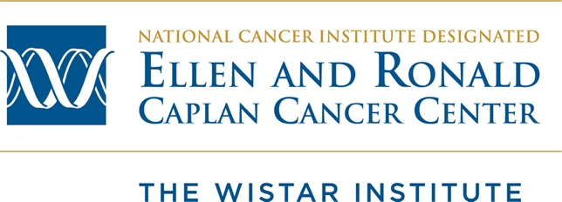

The Wistar Institute
Cancer Biology
University of Pennsylvania BBCB 5850

Semester: Fall 2025
Day and Time: Tuesdays 1:45-4:15pm
Location: Koprowski/Berg Conference Room
The Wistar Institute, 3601 Spruce Street, Philadelphia, PA 19104

Course Directors:
Dr. Italo Tempera, Associate Professor, Genome Regulation and Cell Signaling,
itempera@wistar.org
Dr. Kavitha Sarma, Associate Professor, Genome Regulation and Cell Signaling, ksarma@wistar.org

Teaching Assistants:
Kaitlyn Casey, PhD Student kcasey@wistar.org

Course Description:
The course will cover key pathways and mechanisms of cancer development and progression as well as current approaches for the identification of therapies for the treatment of cancer. The class meets once per week and will begin with a 45-minute lecture followed by group discussion and presentation of that week’s assigned journal article. The paper’s scientific focus will be related to the lecture and it will be posted on the class Canvas site a week in advance.

All students are expected to read the assigned paper prior to class, and to participate in discussions. To promote discussion, students will be organized into groups at the beginning of the semester, with whom they will work until the midpoint of the semester. Each group will be responsible for analyzing and presenting one figure from the paper, although groups won’t know which figure they’re presenting until the class meets. Key points will include:

- What techniques were used to generate the data in the figure?
- What are the positive and negative controls?
- What are the important conclusions of the figure?
- Are there any problems with this conclusion, and what other techniques or experimental approaches could be used to solidify or corroborate the authors’ conclusion?

Then the entire class will discuss a closing summary of the paper and address the following:
- What are the next steps of this research?
- How could this paper have been improved?

The exams consist of short-answer questions related to the assigned papers. The course is designed to provide students with an integrated learning platform, combining up-to-date basic mechanistic understanding of cancer pathways and cutting-edge molecular techniques, with particular emphasis on in-depth critical analysis of the current scientific literature.

Prerequisites: Senior undergraduate or graduate level biochemistry and molecular biology, or prior approval by one of the course directors.

Grading:
Attendance and Class Participation 10%
Exams 2 x 45% = 90%

Schedule:
Introduction to Cancer Biology | Shuda McGuire | August 26
Oncogenic Signaling and the Ras Pathway | Villanueva | September 2
p53 and Tumor Suppressors | Murphy | September 9
Metabolomics | Schug | September 16
Microbiome | Shinde | September 23
Extracellular Vesicles | Bertolini | September 30
Review- Exam I |  | October 7
Cancer Metastasis | Aird | October 14
Tumor Immunology | Zhang | October 21
Cancer Immunotherapy | Claiborne | October 28
Cancer Genomics | Tian | November 5
Cancer Epigenetics | Sarma | November 11
Viruses and Cancer | Tempera | November 18
Thanksgiving Break |  | November 25
Review- Exam II |  | December 2

Please reach out with any questions. We look forward to working with you.

